**Electronic Mail**

**Electronic Mail** (e-mail) is one of most widely used services of [Internet](https://www.geeksforgeeks.org/the-internet-and-the-web/). This service allows an Internet user to send a **message in formatted manner (mail)** to the other Internet user in any part of world. Message in mail not only contain text, but it also contains images, audio and videos data. The person who is sending mail is called **sender** and person who receives mail is called**recipient**. It is just like postal mail service. **Components of E-Mail System:** The basic components of an email system are: User Agent (UA), Message Transfer Agent (MTA), Mail Box, and Spool file. These are explained as following below.

1. **User Agent (UA):** The UA is normally a program which is used to send and receive mail. Sometimes, it is called as mail reader. It accepts variety of commands for composing, receiving and replying to messages as well as for manipulation of the mailboxes.
2. **Message Transfer Agent (MTA):** MTA is actually responsible for transfer of mail from one system to another. To send a mail, a system must have client MTA and system MTA. It transfer mail to mailboxes of recipients if they are connected in the same machine. It delivers mail to peer MTA if destination mailbox is in another machine. The delivery from one MTA to another MTA is done by [Simple Mail Transfer Protocol](https://www.geeksforgeeks.org/simple-mail-transfer-protocol-smtp/).
3. 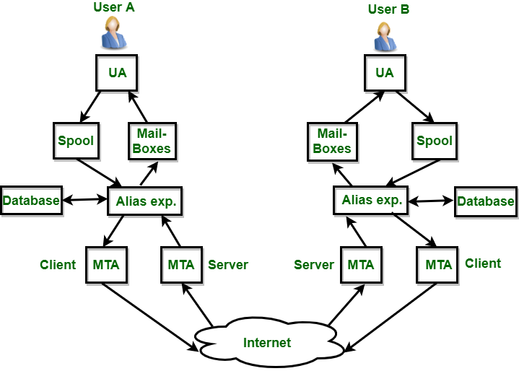
4. **Mailbox:** It is a file on local hard drive to collect mails. Delivered mails are present in this file. The user can read it delete it according to his/her requirement. To use e-mail system each user must have a mailbox. Access to mailbox is only to owner of mailbox.
5. **Spool file:** This file contains mails that are to be sent. User agent appends outgoing mails in this file using SMTP. MTA extracts pending mail from spool file for their delivery. E-mail allows one name, an **alias**, to represent several different e-mail addresses. It is known as **mailing list**, Whenever user have to sent a message, system checks recipient’s name against alias database. If mailing list is present for defined alias, separate messages, one for each entry in the list, must be prepared and handed to MTA. If for defined alias, there is no such mailing list is present, name itself becomes naming address and a single message is delivered to mail transfer entity.

**Services provided by E-mail system:**

* **Composition –** The composition refer to process that creates messages and answers. For composition any kind of text editor can be used.
* **Transfer –** Transfer means sending procedure of mail i.e. from the sender to recipient.
* **Reporting –** Reporting refers to confirmation for delivery of mail. It help user to check whether their mail is delivered, lost or rejected.
* **Displaying –** It refers to present mail in form that is understand by the user.
* **Disposition –** This step concern with recipient that what will recipient do after receiving mail i.e save mail, delete before reading or delete after reading.

## **Architecture of Electronic Mail**

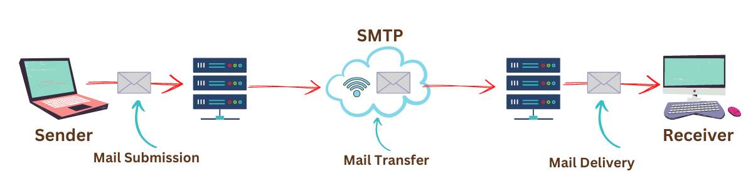

FTP

* FTP stands for File transfer protocol.
* FTP is a standard internet protocol provided by TCP/IP used for transmitting the files from one host to another.
* It is mainly used for transferring the web page files from their creator to the computer that acts as a server for other computers on the internet.
* It is also used for downloading the files to computer from other servers.

## **Mechanism of FTP**

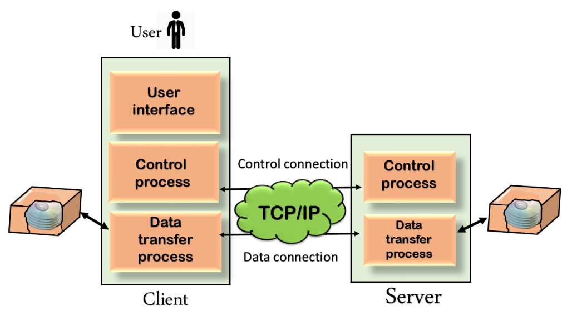

The above figure shows the basic model of the FTP. The FTP client has three components: the user interface, control process, and data transfer process. The server has two components: the server control process and the server data transfer process.

**There are two types of connections in FTP:**

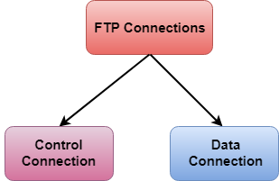

* **Control Connection:** The control connection uses very simple rules for communication. Through control connection, we can transfer a line of command or line of response at a time. The control connection is made between the control processes. The control connection remains connected during the entire interactive FTP session.
* **Data Connection:** The Data Connection uses very complex rules as data types may vary. The data connection is made between data transfer processes. The data connection opens when a command comes for transferring the files and closes when the file is transferred.

## **FTP Clients**

* FTP client is a program that implements a file transfer protocol which allows you to transfer files between two hosts on the internet.
* It allows a user to connect to a remote host and upload or download the files.
* It has a set of commands that we can use to connect to a host, transfer the files between you and your host and close the connection.
* The FTP program is also available as a built-in component in a Web browser. This GUI based FTP client makes the file transfer very easy and also does not require to remember the FTP commands.

### Why is FTP important and what is it used for?

FTP is a standard network protocol that can enable expansive file transfer capabilities across IP networks. Without FTP, file and data transfer can be managed with other mechanisms -- such as email or an HTTP web service -- but those other options lack the clarity of focus, precision and control that FTP enables.

FTP is used for file transfers between one system and another, and it has several common use cases, including the following:

* **Backup.** FTP can be used by [backup services](https://www.techtarget.com/searchdatabackup/tip/Explore-the-best-free-cloud-backup-services-on-the-market) or individual users to backup data from one location to a secured backup server running FTP services.
* **Replication.** Similar to backup, [replication](https://www.computerweekly.com/feature/Storage-101-Replication-vs-backup-and-synchronous-vs-asynchronous) involves duplication of data from one system to another but takes a more comprehensive approach to provide higher availability and resilience. FTP can also be used to facilitate this.
* **Access and data loading.** FTP is also commonly used to access shared web hosting and cloud services as a mechanism to load data onto a remote system.

# HTTP

* HTTP stands for **HyperText Transfer Protocol**.
* It is a protocol used to access the data on the World Wide Web (www).
* The HTTP protocol can be used to transfer the data in the form of plain text, hypertext, audio, video, and so on.
* This protocol is known as HyperText Transfer Protocol because of its efficiency that allows us to use in a hypertext environment where there are rapid jumps from one document to another document.
* HTTP is similar to the FTP as it also transfers the files from one host to another host. But, HTTP is simpler than FTP as HTTP uses only one connection, i.e., no control connection to transfer the files.
* HTTP is used to carry the data in the form of MIME-like format.
* HTTP is similar to SMTP as the data is transferred between client and server. The HTTP differs from the SMTP in the way the messages are sent from the client to the server and from server to the client. SMTP messages are stored and forwarded while HTTP messages are delivered immediately.

## **Features of HTTP:**

* **Connectionless protocol:** HTTP is a connectionless protocol. HTTP client initiates a request and waits for a response from the server. When the server receives the request, the server processes the request and sends back the response to the HTTP client after which the client disconnects the connection. The connection between client and server exist only during the current request and response time only.
* **Media independent:** HTTP protocol is a media independent as data can be sent as long as both the client and server know how to handle the data content. It is required for both the client and server to specify the content type in MIME-type header.
* **Stateless:** HTTP is a stateless protocol as both the client and server know each other only during the current request. Due to this nature of the protocol, both the client and server do not retain the information between various requests of the web pages.

## **HTTP Transactions**

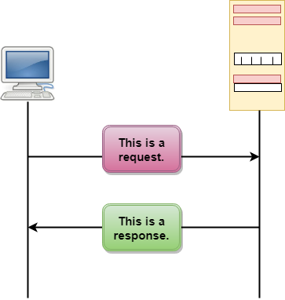

The above figure shows the HTTP transaction between client and server. The client initiates a transaction by sending a request message to the server. The server replies to the request message by sending a response message.

## **Messages**

HTTP messages are of two types: request and response. Both the message types follow the same message format.

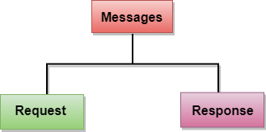

**Request Message:** The request message is sent by the client that consists of a request line, headers, and sometimes a body.

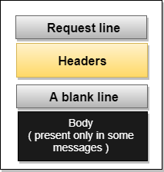

**Response Message:** The response message is sent by the server to the client that consists of a status line, headers, and sometimes a body.